**Tutorial 1**

**Task 1**

import java.util.Scanner;  
  
public class Task1LengthCent {  
 public static void main(String[] args) {  
 for(int i=0; i<3 ;i++) {  
 Scanner input = new Scanner(System.*in*);  
 System.*out*.println("Enter length in centimetres: ");  
 double value = input.nextDouble();  
  
 double conversion = (value * 0.393);  
  
 System.*out*.println(value + " centimetres converts into " + conversion + " inches");  
 }  
 }  
}

3 example outputs

import java.util.Scanner;  
  
public class Task1LengthInt {  
 public static void main(String[] args){  
 for(int i=0; i<3; i++) {  
 Scanner input = new Scanner(System.*in*);  
 System.*out*.println("Enter length in inches: ");  
 double value = input.nextDouble();  
  
 double conversion = (value * 2.54);  
  
 System.*out*.println(value + " inches converts into " + conversion + " centimetres");  
 }  
 }  
}

import java.util.Scanner;  
  
public class Task1LengthMet {  
 public static void main(String[] args) {  
 for(int i=0; i<3; i++) {  
 Scanner input = new Scanner(System.*in*);  
 System.*out*.println("Enter length in metres: ");  
 double value = input.nextDouble();  
  
 double conversion = (value * 3.281);  
  
 System.*out*.println(value + " metres converts into " + conversion + " feet");  
 }  
 }  
}

import java.util.Scanner;  
  
public class Task1LengthFoot {  
 public static void main(String[] args) {  
 for(int i=0; i<3 ;i++) {  
 Scanner input = new Scanner(System.*in*);  
 System.*out*.println("Enter length in feet: ");  
 double value = input.nextDouble();  
  
 double conversion = (value * 0.305);  
  
 System.*out*.println(value + " feet converts into " + conversion + " metres");  
 }  
 }  
}

import java.util.Scanner;  
  
public class Task1LengthKilo {  
 public static void main(String[] args) {  
 for(int i=0; i<3; i++) {  
 Scanner input = new Scanner(System.*in*);  
 System.*out*.println("Enter length in kilometres: ");  
 double value = input.nextDouble();  
  
 double conversion = (value * 0.621);  
  
 System.*out*.println(value + " kilometres converts into " + conversion + " miles");  
 }  
 }  
}

import java.util.Scanner;  
  
public class Task1LengthMil {  
 public static void main(String[] args) {  
 for(int i=0; i<3; i++) {  
 Scanner input = new Scanner(System.*in*);  
 System.*out*.println("Enter length in miles: ");  
 double value = input.nextDouble();  
  
 double conversion = (value * 1.609);  
  
 System.*out*.println(value + " miles converts into " + conversion + " kilometres");  
 }  
 }  
}

import java.util.Scanner;  
  
public class Task1WeightGram {  
 public static void main(String[] args) {  
 for(int i=0; i<3; i++) {  
 Scanner input = new Scanner(System.*in*);  
 System.*out*.println("Enter length in grams: ");  
 double value = input.nextDouble();  
  
 double conversion = (value * 0.035);  
  
 System.*out*.println(value + " grams converts into " + conversion + " ounces");  
 }  
 }  
}

import java.util.Scanner;  
  
public class Task1WeightOunc {  
 public static void main(String[] args) {  
 for(int i=0; i<3; i++) {  
 Scanner input = new Scanner(System.*in*);  
 System.*out*.println("Enter length in ounces: ");  
 double value = input.nextDouble();  
  
 double conversion = (value * 28.35);  
  
 System.*out*.println(value + " ounces converts into " + conversion + " grams");  
 }  
 }  
}

import java.util.Scanner;  
  
public class Task1WeightKiGram {  
 public static void main(String[] args) {  
 for (int i = 0; i < 3; i++) {  
 Scanner input = new Scanner(System.*in*);  
 System.*out*.println("Enter length in kilograms: ");  
 double value = input.nextDouble();  
  
 double conversion = (value * 2.204);  
  
 System.*out*.println(value + " kilograms converts into " + conversion + " pounds");  
 }  
 }  
}

import java.util.Scanner;  
  
public class Task1WeightPoun {  
 public static void main(String[] args) {  
 for (int i = 0; i < 3; i++) {  
 Scanner input = new Scanner(System.*in*);  
 System.*out*.println("Enter length in pounds: ");  
 double value = input.nextDouble();  
  
 double conversion = (value * 2.204);  
  
 System.*out*.println(value + " pounds converts into " + conversion + " kilograms");  
 }  
 }  
}

import java.util.Scanner;  
  
public class Task1VolumeMil {  
 public static void main(String[] args) {  
 for (int i = 0; i < 3; i++) {  
 Scanner input = new Scanner(System.*in*);  
 System.*out*.println("Enter length in millilitre: ");  
 double value = input.nextDouble();  
  
 double conversion = (value * 0.035);  
  
 System.*out*.println(value + " millilitre converts into " + conversion + " fluid ounces");  
 }  
 }  
}

import java.util.Scanner;  
  
public class Task1VolumeFlu {  
 public static void main(String[] args) {  
 for (int i = 0; i < 3; i++) {  
 Scanner input = new Scanner(System.*in*);  
 System.*out*.println("Enter length in fluid ounces: ");  
 double value = input.nextDouble();  
  
 double conversion = (value * 28.413);  
  
 System.*out*.println(value + " fluid ounces converts into " + conversion + " millilitres");  
 }  
 }  
}

import java.util.Scanner;  
  
public class Task1VolumeLit {  
 public static void main(String[] args) {  
 for (int i = 0; i < 3; i++) {  
 Scanner input = new Scanner(System.*in*);  
 System.*out*.println("Enter length in litres: ");  
 double value = input.nextDouble();  
  
 double conversion = (value * 0.878);  
  
 System.*out*.println(value + " litres converts into " + conversion + " quarts");  
 }  
 }  
}

import java.util.Scanner;  
  
public class Task1VolumeQuar {  
 public static void main(String[] args) {  
 for (int i = 0; i < 3; i++) {  
 Scanner input = new Scanner(System.*in*);  
 System.*out*.println("Enter length in quarts: ");  
 double value = input.nextDouble();  
  
 double conversion = (value * 1.137);  
  
 System.*out*.println(value + " quarts converts into " + conversion + " litres");  
 }  
 }  
}

Entering something that isn’t a number into the prompt and note what occurs (and why).

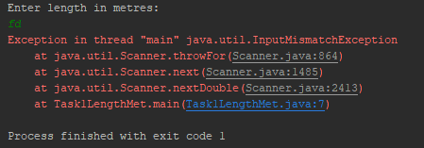

The scanner is expecting a number as an input because “ .nextDouble() ” has been used with the scanner variable. Therefore, only numbers are accepted as the input.

**Task 2**

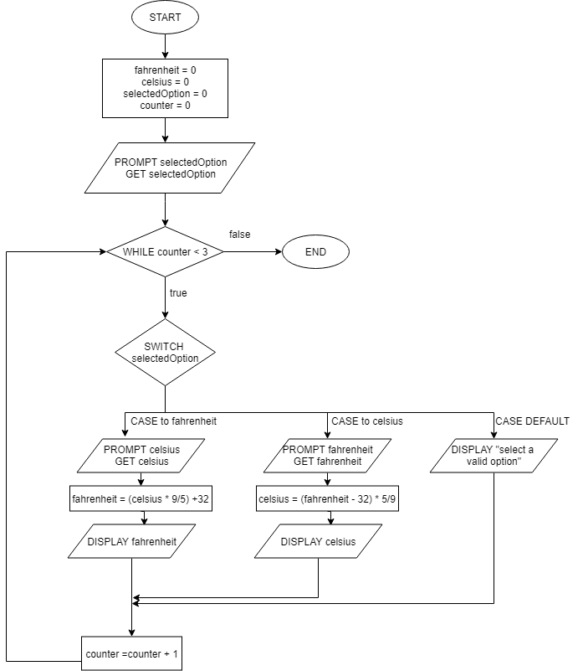

1.BEGIN

2.SET fahrenheit = 0, celsius = 0, selectedOption = "", counter=0

3Prompt selectedOption

4.GET selectedOption

5.DO WHILE counter<3

6. If selectedOption = "fahrenheit":

7. PROMPT celsius

8. GET celsius

9. fahrenheit = (celsius*9/5)+32

10. Display " fahrenheit temperature of celsius "+celsius+":"+fahrenheit

11. ELSE IF selectedOption = "celsius":

12. PROMPT fahrenheiht

13. GET fahrenheit

14. celsius = (fahrenheit-32)*5/9

15. DISPLAY " celsius temperature of the fahrenheit "+fahrenheit+"=",celsius

16. ELSE:

17. DISPLAY "select a valid option"

END IF

END IF

18. counter = counter + 1

END DO

END

import java.util.Scanner;  
  
public class Task2TempCel {  
 public static void main(String[] args) {  
 for (int i = 0; i < 7; i++) {  
 Scanner input = new Scanner(System.*in*);  
 System.*out*.println("\nEnter temperature in Celsius: ");  
 double value = input.nextDouble();  
  
 double conversion = (value - 32) * 5 / 9;  
 double roundedConv = (double) Math.*round*(conversion * 100) / 100;  
  
 System.*out*.println(value + " fahrenheit converts into " + roundedConv + " celsius");  
 }  
 }  
}

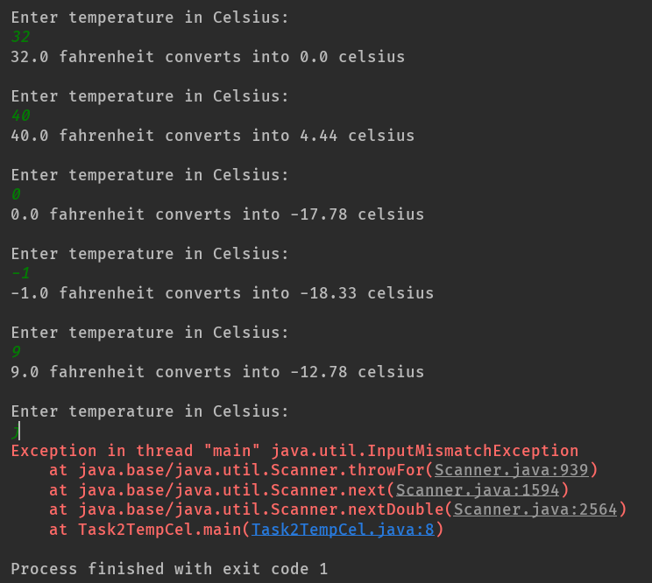

|  |  |  |
| --- | --- | --- |
| Input | Expected Ouput | Output |
| 32 | 0 | 0 |
| 40 | 4.44 | 4.44 |
| 0 | -17.78 | -17.78 |
| -1 | -18.33 | -18.33 |
| 9 | -12.78 | -12.78 |
| j | Error | java.util.InputMismatchException |
| @ | Error | java.util.InputMismatchException |

import java.util.Scanner;  
  
public class Task2TempFah {  
 public static void main(String[] args) {  
 for (int i = 0; i < 7; i++) {  
 Scanner input = new Scanner(System.*in*);  
 System.*out*.println("\nEnter temperature in fahrenheit: ");  
 double value = input.nextDouble();  
  
 double conversion = ((value * 9) / 5) + 32;  
 double roundedConv = (double) Math.*round*(conversion * 100) / 100;  
  
 System.*out*.println(value + " celsius converts into " + roundedConv + " fahrenheit");  
 }  
 }  
}

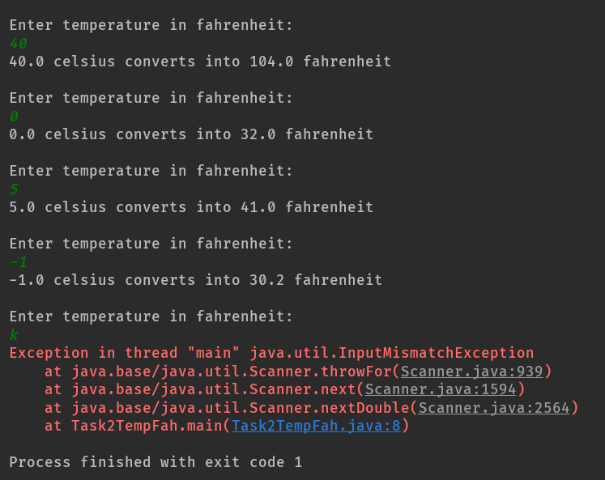

|  |  |  |
| --- | --- | --- |
| Input | Expected Ouput | Output |
| 1/9 | 6.4 | java.util.InputMismatchException |
| 40 | 104 | 104.0 |
| 0 | 32 | 32.0 |
| -1 | 30.2 | 30.2 |
| 5 | 41 | 41.0 |
| k | Error | java.util.InputMismatchException |
| @ | Error | java.util.InputMismatchException |

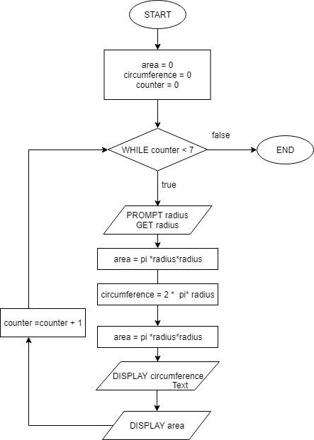

1.BEGIN

2.SET area = 0, circumference = 0, counter = 0

3.PROMPT radius

4.GET radius

5.area=Math.pi()*(radius*radius)

6.circumference=2*pi*radius

7.DISPLAY "Circumference="+circumference

8.DISPLAY "Area="+area

END

import java.util.Scanner;  
  
public class Task2Geometry {  
 public static void main(String[] args) {  
 for (int i = 0; i < 7; i++) {  
 Scanner input = new Scanner(System.*in*);  
 System.*out*.println("\nEnter the radius of the circle: ");  
 double radius = input.nextDouble();  
  
 double area = Math.*PI* * (radius * radius);  
 double roundedArea = (double) Math.*round*(area * 100) / 100;  
  
 double circumference = 2* Math.*PI* * (radius);  
 double roundedCircum= (double) Math.*round*(circumference * 100) / 100;  
  
  
 System.*out*.println("The area of the circle: "+roundedArea);  
 System.*out*.println("The circumference of the circle: "+roundedCircum);  
  
 }  
 }  
}

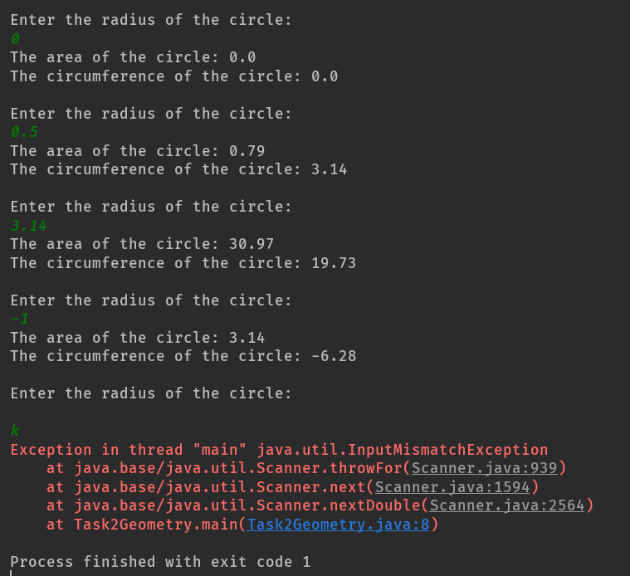

|  |  |  |  |  |
| --- | --- | --- | --- | --- |
| Input | Expected circumference | Expected area | Ouput circumference | Ouput area |
| 0 | 0 | 0 | 0.0 | 0.0 |
| 0.5 | 3.14 | 0.79 | 3.14 | 0.79 |
| 3.14 | 19.73 | 30.97 | 19.73 | 30.97 |
| -1 | 6.28 | 3.14 | -6.28 | 3.14 |
| “ ” | Error | Error |  |  |
| k | Error | Error | java.util.InputMismatchException | java.util.InputMismatchException |
| @ | Error | Error | java.util.InputMismatchException | java.util.InputMismatchException |

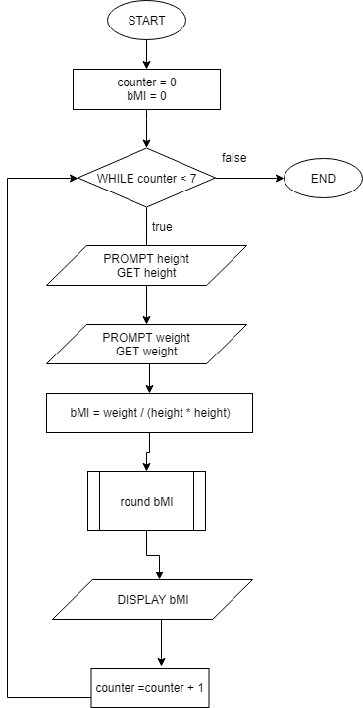

1.BEGIN

2.PROMPT weight

3.GET weight

4.PROMPT height

5.GET height

6.bMI = weight/(height*height);

7.DISPLAY "Your BMI IS: "+bMI

End

import java.util.Scanner;  
  
public class Task2Nutrition {  
 public static void main(String[] args) {  
 for (int i = 0; i < 7; i++) {  
 Scanner input = new Scanner(System.*in*);  
 System.*out*.print("\nEnter your weight (in Kilograms): ");  
 double weight = input.nextDouble();  
  
 System.*out*.print("Enter your height (in Metres): ");  
 double height = input.nextDouble();  
  
 double bMI = weight / (height * height);  
 bMI = (double) Math.*round*(bMI*100)/100;  
  
 System.*out*.println("Your BMI is: " + bMI);  
  
 System.*out*.println("-----------------------------------");  
 }  
 }  
}

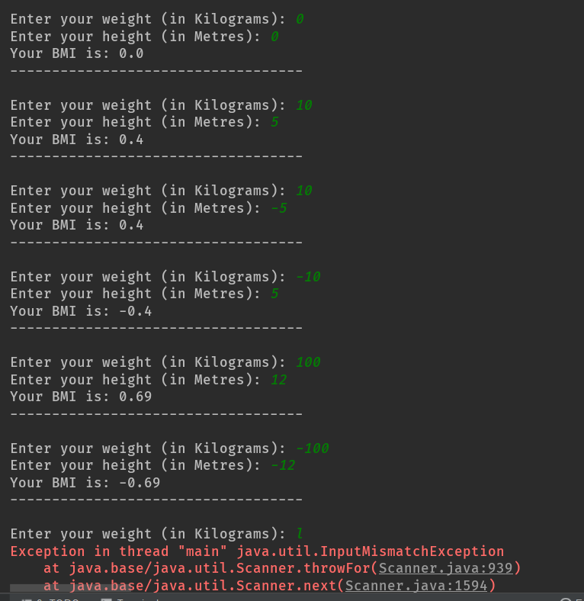

|  |  |  |  |
| --- | --- | --- | --- |
| Input weight | Input height | Expected Ouput | Output |
| 0 | 0 | 0 | 0.0 |
| 10 | 5 | 0.4 | 0.4 |
| 10 | -5 | 0.4 | 0.4 |
| -10 | 5 | -0.4 | -0.4 |
| -100 | -12 | -0.69 | -0.69 |
| l |  | Error | java.util.InputMismatchException |
| @ |  | Error | java.util.InputMismatchException |

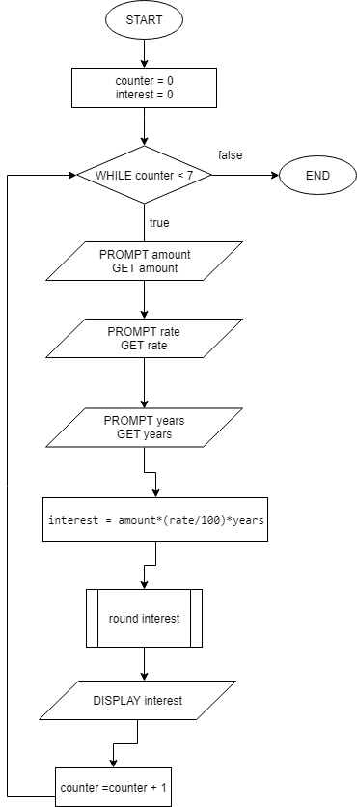

1.BEGIN

2.PROMPT amount

3.GET amount

4.PROMPT rate

5.GET rate

6.PROMPT years

7.GET years

8.interest=amount*(rate/100)*years

9.DISPLAY "Your interest is: "+interest

END

import java.util.Scanner;  
  
public class Task2Finance {  
 public static void main(String[] args) {  
 for (int i = 0; i < 7; i++) {  
 Scanner input = new Scanner(System.*in*);  
 System.*out*.print("\nEnter loan amount (in $): ");  
 double amount = input.nextDouble();  
  
 System.*out*.print("Enter annual interest rate (in %): ");  
 double rate = input.nextDouble();  
  
 System.*out*.print("Enter time period (in years): ");  
 double years = input.nextDouble();  
  
 double interest = amount*(rate/100)*years;  
 interest = (double) Math.*round*(interest*100)/100;  
  
 System.*out*.println("Your interest is: $" + interest);  
  
 System.*out*.println("-----------------------------------");  
 }  
 }  
}

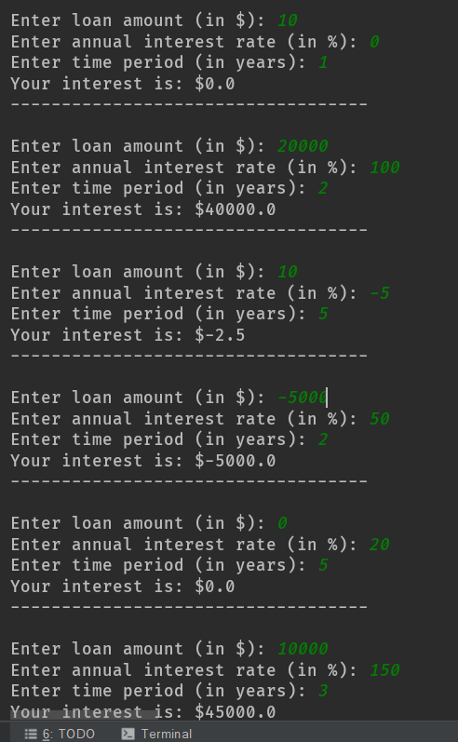

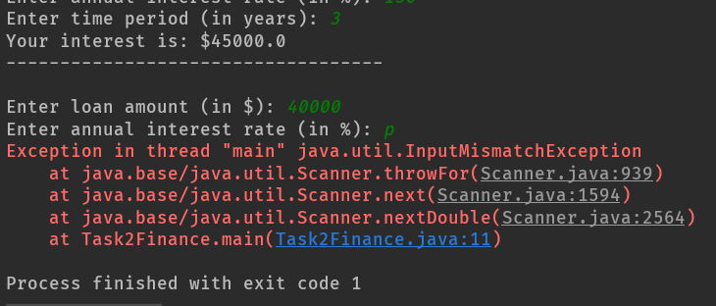

|  |  |  |  |  |
| --- | --- | --- | --- | --- |
| Input amount | Input rate | Input years | Expected Ouput | Output (interest) |
| 10 | 0 | 1 | 0 | 0.0 |
| 20000 | 100 | 2 | 40000 | 40000 |
| 10 | -5 | 5 | Error | -2.5 |
| -5000 | 50 | 2 | -5000 | -5000.0 |
| 10000 | 150 | 3 | Error | 45000 |
| 40000 | p |  | Error | java.util.InputMismatchException |
| @ |  |  | Error | java.util.InputMismatchException |

Math.round() Ref: <https://stackoverflow.com/questions/11701399/round-up-to-2-decimal-places-in-java/11701527>